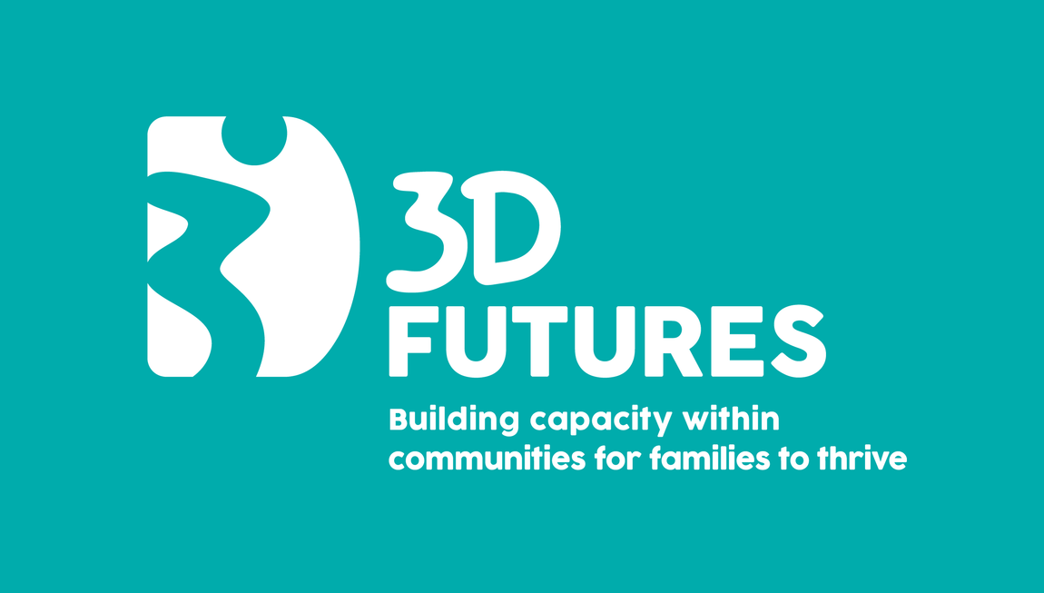
3D Futures ‘Family Support Essentials’
Training programme for Churches to build capacity to deliver family support in the communities where you serve
Format: 10-Week Online Programme - Book individual sessions or come to them all!
Time: 7:00pm – 9:00pm (join from 6:45pm, optional Q&A until 9:15pm)
Cost: £30 per session
Facilitators: Sharon Colvin &/or Marion Lindsay
For more info: Contact 3dfutures@3dfamilies.org.uk / www.3dfamilies.org.uk
At 3D Families (formerly 3D Drumchapel), we have been working with and supporting children and families for over 27 years. Over the course of this time, with our experience and gained wisdom, we have created a robust locality model for family support that has evidenced a transformative impact on children and families in Drumchapel. This model includes quality frontline family support approaches and services embedded in our community along with a collaborative model for systems change, working with local partners to change the landscape with and for children and families to create effective and lasting change. Our model is widely recognised as a beacon of best practice and we are excited to be able to support other communities to grow your own capacity to affect the same change.
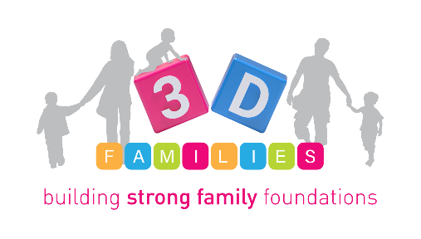

Date | Session Title | Description | Session aims | Booking Link
Thursday 23rd April | Engaging with Families | Explores effective ways to connect with families in community settings, focusing on empathy, communication, and understanding diverse family needs. | Learn different ways to engage with families, including the what, how, when and where  Co-design services with families  Explore how to engage those who do not reach out  Understand and consider how to respond to individual family needs | https://events.humanitix.com/3d-futures-engaging-with-families-training-session
Thursday 30th April | Building Therapeutic & Trusting Relationships | Covers principles of trust-building, active listening, and creating safe spaces for families to share and grow. | Consider the principles & qualities required by a family worker  Consider the importance of good relationships  Explore different tools & concepts to support building trusting relationships  Understand importance and effective methods for co-regulation | https://events.humanitix.com/building-therapeutic-and-trusting-relationships
Thursday 7th May | Supporting the Parent to Support the Child | Focuses on empowering parents with tools and strategies to strengthen their relationships with their children and promote positive family dynamics. | Explore what a child needs to thrive & learn key parenting strategies & messages to support each need  Understand your role in supporting the parent to support their child to thrive looking at ways to do this | https://events.humanitix.com/supporting-the-parent-to-support-the-child
Thursday 14th May | Introduction to Trauma | Introduces trauma-informed approaches, helping participants understand the impact of trauma on families and how to respond with sensitivity and care. | Understand causes & impact of trauma  Explore how to support families articulate, process and heal from their own trauma  Consider how to support parents to prevent future trauma  Learn how to ensure your service is trauma-informed and trauma-responsive | https://events.humanitix.com/introduction-to-trauma
Thursday 21st May | Supporting Families Through Play | Highlights the importance of play in child development and family bonding, offering practical ways to use play as a support tool. | Understand the benefits of play for children & families including outdoor play & risky play  Learn & participate in play activities to engage families of all ages & stages | https://events.humanitix.com/supporting-families-through-play
Thursday 28th May | Facilitating Peer Support Groups | Provides guidance on setting up and leading peer support groups within church communities to foster mutual encouragement and shared learning. | Explore the benefits & impact of peer support  Consider ways to engage parents in peer support groups  Learn skills & tools to facilitate peer support groups including ‘top tips’ for peer support facilitation | https://events.humanitix.com/facilitating-peer-support-groups
Thursday 4th June | Family Support & Neurodiversity | Explores how to support families with neurodiverse members, promoting inclusion, understanding, and tailored approaches. | Learn about key aspects of neurodiversity including some of the strengths & challenges impacting children & families  Learn about our own services in this area and gain wisdom from our experience and learning in relation to engagement with families & stakeholders and providing support  Explore parenting strategies for supporting neurodivergent children | https://events.humanitix.com/family-support-and-neurodiversity
Thursday 11th June | Delivering Perinatal Family Support | Focuses on supporting families during pregnancy and early parenthood, addressing emotional wellbeing and early attachment. | Learn key theory around the importance of supporting families through the perinatal stage  Learn about our own perinatal services  Explore ways to engage families in the perinatal stage  Explore the key messages for families during the perinatal stage | https://events.humanitix.com/delivering-perinatal-family-support
Thursday 18th June | Leadership in Family Support | Develops leadership skills for those coordinating or leading family support initiatives within church contexts. | Explore key aspects of effective leadership in family support  Learn how to create and embed the right ethos within and throughout your family support work which establishes the culture you require  Create a culture of creative, innovative & reflective practice | https://events.humanitix.com/leadership-in-family-support
Thursday 25th June | Resourcing Your Family Support Work | Covers practical tools, funding opportunities, and community partnerships to sustain and grow family support programmes. | Learn ‘Top Tips’ for securing & reporting on funding  Explore different ways of raising your own income through fundraising and contracts  Build the right team for your work by exploring how to recruit and retain good staff, volunteers and board members  Consider opportunities to work with partners | https://events.humanitix.com/resourcing-your-family-support-work

Our facilitators
Marion Lindsay is our Senior Children Family Worker and has 26 years experience working with children and families at 3D Families. Marion is a trained facilitator in many programmes including Triple P, Solihull Understanding your Child, Baby Massage, Seasons for Growth and Safe Spaces. Marion also facilitates parent & child sessions, outdoor play sessions, peer support groups, home visits and one to one support for parents. Marion has been a lead pioneer in developing and facilitating new services at 3D including our ‘Muddy Buddies’ outdoor play programme and 3D Thrive’ delivering intensive family support for families referred to us by Social Work “Marion has years of experience facilitating a wide variety of groups within 3D and is a fountain of knowledge on many topics pertaining to family support. She is an excellent communicator and instantly puts people at ease. Marion listens to people and gains their trust all while managing to encourage them to have the courage to be open and honest resulting in participants getting the most out of every session” Triple p co-facilitator

Sharon Colvin is our Chief Executive and has been leading the work at 3D for the past 18 years. Sharon has a community work degree and has spent time as a community worker in the East End of Glasgow and also living and volunteering at community development projects in South America. Sharon is a Solihull trainer and has completed the Scottish Coaching Leadership for Improvement Programme with the Scottish Government and the Trauma informed Leadership programme with NHS Education Scotland. Sharon established and leads the Drumchapel Children Families Network which brings together all sectors to build relationships, share best practice and deliver innovative change with and for children families. "Sharon is an excellent trainer with a sound knowledge of the subjects she delivers It is evident that additional reading and study is undertaken and this gives additional value to the content Sharon has a kind, caring and nurturing manner that engages participants and builds a level of trust in the group where people feel safe to share experiences, learn and grow together It is always a pleasure to co-deliver with her” Solihull co-trainer

We are also available to provide training in your own community and can also provide consultancy and coaching support with the offer to shadow some of our work at 3D Families in Drumchapel. Please browse our 3D Futures brochure for our full offer here: https://tinyurl.com/3DFutures Please get in touch if would like further information or would like to discuss the possibility of delivering this in your own community – 3dfutures@3dfamilies.org.uk

We were delighted to deliver our pilot programme in Stewarton with the pioneer projects across churches in East Ayrshire.

“3D Futures has had a pivotal impact in helping create a sustainable vibrant kingdom expression in Stewarton by giving us a toolbox of practical strategies to enhance our community engagement, build capacity and foster relationships. The support, knowledge and experience shared from Marion and Sharon has been invaluable and will have an effective and lasting impact on the families we support“ Sarah McLachlan, Thrive Stewarton

Here also is a recent briefing paper which provides some context of the work of 3D Families https://tinyurl.com/3dbriefingpaper

